**Міністерство освіти і науки України**

**Національний технічний університет України**

**“Київський політехнічний інститут”**

**Факультет прикладної математики**

**Кафедра спеціалізованих комп’ютерних систем**

**Лабораторна робота № 3**

з дисципліни «Схемотехніка»

«Проектування регістра на потенціальних елементах»



Виконав:

студент групи КВ-43

**Вітовщик Михайло**

Перевірив:

Клятченко Я.М.

\_\_\_\_\_\_\_\_\_\_\_\_\_\_\_\_\_\_\_\_\_\_\_\_\_\_\_\_\_\_\_\_\_\_\_\_

Київ 2015

Варіант 10101

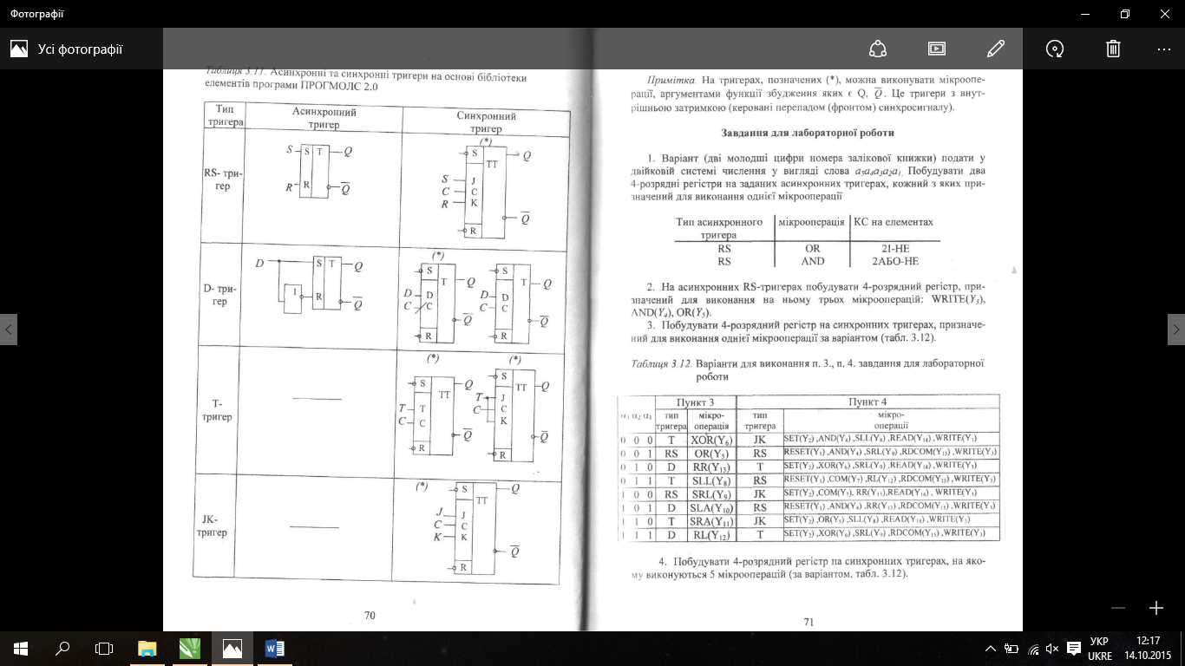

1. Побудувати 4-розрядний регістр на синхронних тригерах, на якому виконуються 5 мікроперацій за варіантом

2014-11-10_20-04-26

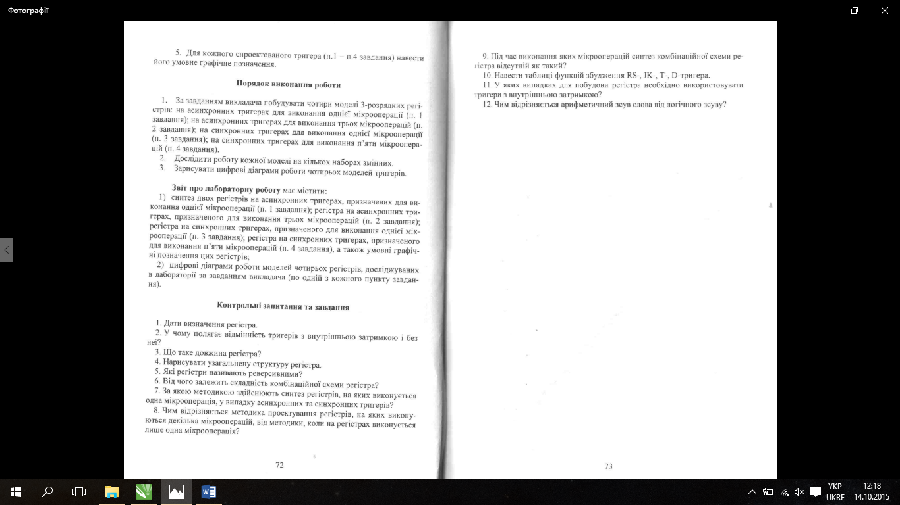

1. Синтез двох регістрів на заданих асинхронних тригерах

AND(Y4)

Qi(t+1) = Qi(t) & Xi(t)

|  |  |  |  |
| --- | --- | --- | --- |
| Q(t) | Q(t+1) | F1 | F2 |
| 0 | 0 | \* | 0 |
| 0 | 1 | 0 | 1 |
| 1 | 0 | 1 | 0 |
| 1 | 1 | 0 | \* |

|  |  |  |  |  |  |
| --- | --- | --- | --- | --- | --- |
| Y4 | X(t) | Q(t) | Q(t+1) | F1 | F2 |
| 0 | 0 | 0 | 0 | \* | 0 |
| 0 | 0 | 1 | 1 | 0 | \* |
| 0 | 1 | 0 | 0 | \* | 0 |
| 0 | 1 | 1 | 1 | 0 | \* |
| 1 | 0 | 0 | 0 | \* | 0 |
| 1 | 0 | 1 | 0 | 1 | 0 |
| 1 | 1 | 0 | 0 | \* | 0 |
| 1 | 1 | 1 | 1 | 0 | \* |

|  |  |  |  |
| --- | --- | --- | --- |
| \* | 0 | 1 | \* |
| \* | 0 | 0 | \* |

|  |  |  |  |
| --- | --- | --- | --- |
| 0 | \* | 0 | 0 |
| 0 | \* | \* | 0 |

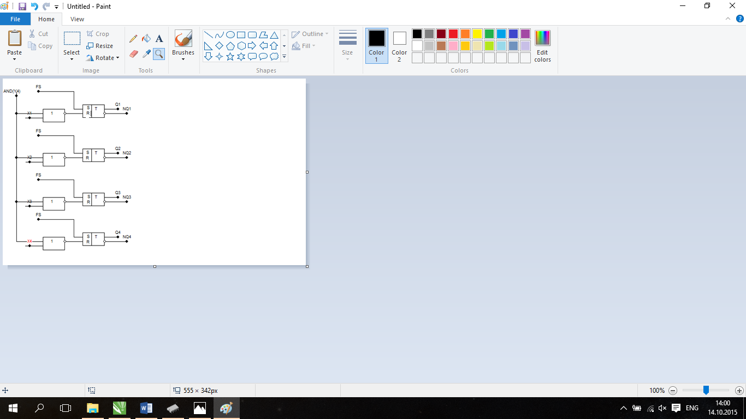

|  |  |  |  |
| --- | --- | --- | --- |
| Q(t) | Q(t+1) | F1 | F2 |
| 0 | 0 | \* | 0 |
| 0 | 1 | 0 | 1 |
| 1 | 0 | 1 | 0 |
| 1 | 1 | 0 | \* |

OR(Y5)

Qi(t+1) = Qi(t) v Xi(t)

|  |  |  |  |  |  |
| --- | --- | --- | --- | --- | --- |
| Y5 | X(t) | Q(t) | Q(t+1) | F1 | F2 |
| 0 | 0 | 0 | 0 | \* | 0 |
| 0 | 0 | 1 | 1 | 0 | \* |
| 0 | 1 | 0 | 0 | \* | 0 |
| 0 | 1 | 1 | 1 | 0 | \* |
| 1 | 0 | 0 | 0 | \* | 0 |
| 1 | 0 | 1 | 1 | 0 | \* |
| 1 | 1 | 0 | 1 | 0 | 1 |
| 1 | 1 | 1 | 1 | 0 | \* |

|  |  |  |  |
| --- | --- | --- | --- |
| 0 | 0 | 0 | \* |
| \* | 0 | 0 | \* |

|  |  |  |  |
| --- | --- | --- | --- |
| 1 | \* | \* | 0 |
| 0 | \* | \* | 0 |

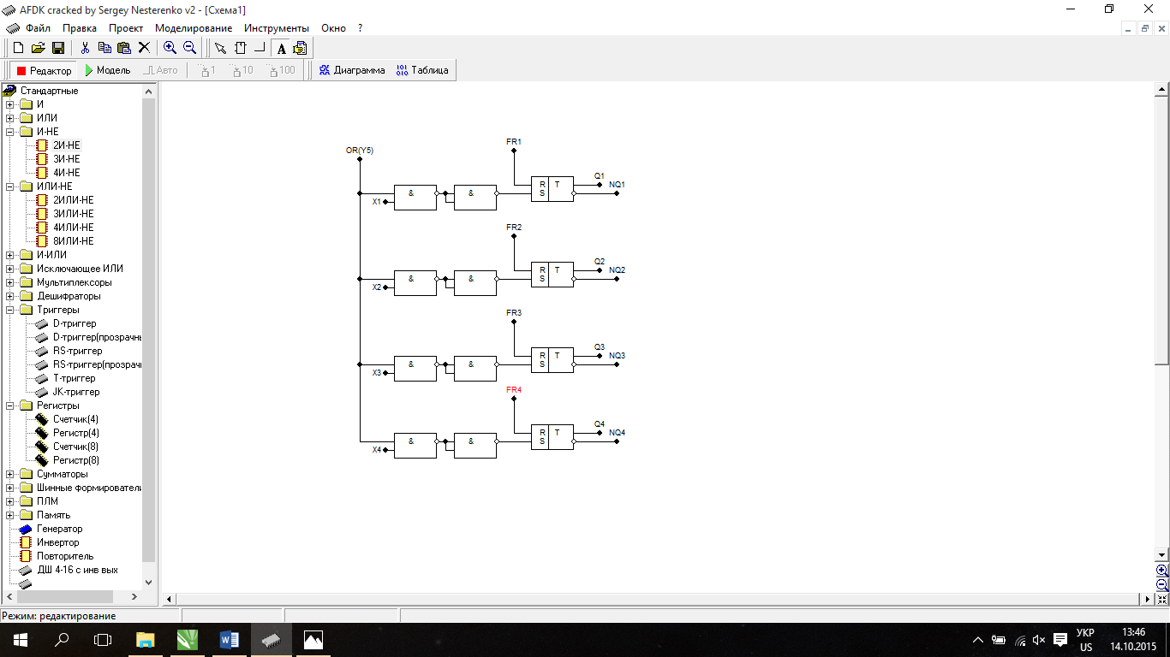

1. Чотирьохрозрядний регістр для трьох мікрооперацій на асинхронних RS-тригерах

|  |  |  |  |
| --- | --- | --- | --- |
| Q(t) | Q(t+1) | F1 | F2 |
| 0 | 0 | \* | 0 |
| 0 | 1 | 0 | 1 |
| 1 | 0 | 1 | 0 |
| 1 | 1 | 0 | \* |

WRITE(Y3) Qi(t+1) = Xi(t)

|  |  |  |  |  |  |
| --- | --- | --- | --- | --- | --- |
| Y3 | X(t) | Q(t) | Q(t+1) | F1 | F2 |
| 0 | 0 | 0 | 0 | \* | 0 |
| 0 | 0 | 1 | 1 | 0 | \* |
| 0 | 1 | 0 | 0 | \* | 0 |
| 0 | 1 | 1 | 1 | 0 | \* |
| 1 | 0 | 0 | 0 | \* | 0 |
| 1 | 0 | 1 | 0 | 1 | 0 |
| 1 | 1 | 0 | 1 | 0 | 0 |
| 1 | 1 | 1 | 1 | 0 | \* |

|  |  |  |  |
| --- | --- | --- | --- |
| 0 | 0 | 1 | \* |
| \* | 0 | 0 | \* |

|  |  |  |  |
| --- | --- | --- | --- |
| 1 | \* | 0 | 0 |
| 0 | \* | \* | 0 |

OR(Y5) Qi(t+1) = Qi(t) v Xi(t)

|  |  |  |  |  |  |
| --- | --- | --- | --- | --- | --- |
| Y5 | X(t) | Q(t) | Q(t+1) | F1 | F2 |
| 0 | 0 | 0 | 0 | \* | 0 |
| 0 | 0 | 1 | 1 | 0 | \* |
| 0 | 1 | 0 | 0 | \* | 0 |
| 0 | 1 | 1 | 1 | 0 | \* |
| 1 | 0 | 0 | 0 | \* | 0 |
| 1 | 0 | 1 | 1 | 0 | \* |
| 1 | 1 | 0 | 1 | 0 | 1 |
| 1 | 1 | 1 | 1 | 0 | \* |

|  |  |  |  |
| --- | --- | --- | --- |
| 0 | 0 | 0 | \* |
| \* | 0 | 0 | \* |

|  |  |  |  |
| --- | --- | --- | --- |
| 1 | \* | \* | 0 |
| 0 | \* | \* | 0 |

AND(Y4) Qi(t+1) = Qi(t) & Xi(t)

|  |  |  |  |  |  |
| --- | --- | --- | --- | --- | --- |
| Y4 | X(t) | Q(t) | Q(t+1) | F1 | F2 |
| 0 | 0 | 0 | 0 | \* | 0 |
| 0 | 0 | 1 | 1 | 0 | \* |
| 0 | 1 | 0 | 0 | \* | 0 |
| 0 | 1 | 1 | 1 | 0 | \* |
| 1 | 0 | 0 | 0 | \* | 0 |
| 1 | 0 | 1 | 0 | 1 | 0 |
| 1 | 1 | 0 | 0 | \* | 0 |
| 1 | 1 | 1 | 1 | 0 | \* |

|  |  |  |  |
| --- | --- | --- | --- |
| \* | 0 | 1 | \* |
| \* | 0 | 0 | \* |

|  |  |  |  |
| --- | --- | --- | --- |
| 0 | \* | 0 | 0 |
| 0 | \* | \* | 0 |

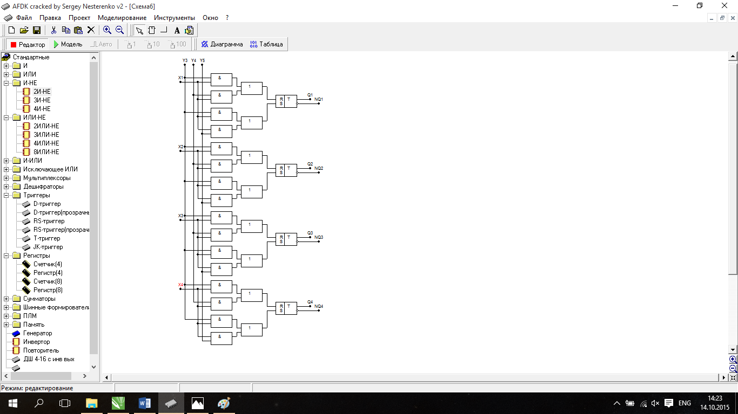

3.Синтез решістра на синхронних тригерах, на якому виконується одна мікрооперація

|  |  |  |
| --- | --- | --- |
| Q(t) | Q(t+1) | Fd |
| 0 | 0 | 0 |
| 0 | 1 | 1 |
| 1 | 0 | 0 |
| 1 | 1 | 1 |

SLA(Y10)

|  |  |  |  |  |
| --- | --- | --- | --- | --- |
| Y12 | Qi-1(t) | Q(t) | Q(t+1) | Fd |
| 0 | 0 | 0 | 0 | 0 |
| 0 | 0 | 1 | 1 | 1 |
| 0 | 1 | 0 | 0 | 0 |
| 0 | 1 | 1 | 1 | 1 |
| 1 | 0 | 0 | 0 | 0 |
| 1 | 0 | 1 | 0 | 0 |
| 1 | 1 | 0 | 1 | 1 |
| 1 | 1 | 1 | 1 | 1 |

|  |  |  |  |
| --- | --- | --- | --- |
| 1 | 1 | 0 | 0 |
| 0 | 1 | 1 | 0 |

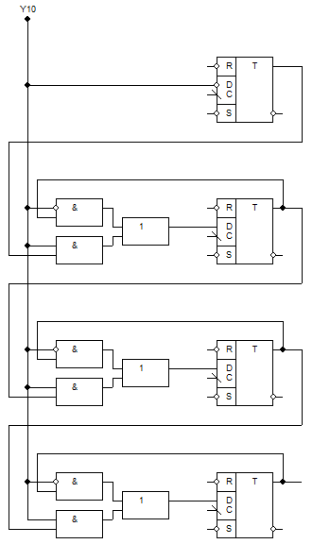

4.Синтез регістра на синхронних тригерах, на яких виконується декілька мікрооперацій

|  |  |  |  |
| --- | --- | --- | --- |
| Q(t) | Q(t+1) | Fr | Fs |
| 0 | 0 | \* | 0 |
| 0 | 1 | 0 | 1 |
| 1 | 0 | 1 | 0 |
| 1 | 1 | 0 | \* |

1)Reset(Y1)-вставити всі розряди регістра в «0», на всі асинхронні входи подати логічний нуль

2) AND(Y4) - див завдання 1.

Qi(t+1) = Qi(t) & Xi(t)

RR(Y13)

|  |  |  |  |  |  |
| --- | --- | --- | --- | --- | --- |
| Y9 | Qi+1(t) | Qi(t) | Qi(t+1) | Fri | Fsi |
| 0 | 0 | 0 | 0 | \* | 0 |
| 0 | 0 | 1 | 1 | 0 | \* |
| 0 | 1 | 0 | 0 | \* | 0 |
| 0 | 1 | 1 | 1 | 0 | \* |
| 1 | 0 | 0 | 0 | \* | 0 |
| 1 | 0 | 1 | 0 | 1 | 0 |
| 1 | 1 | 0 | 1 | 0 | 1 |
| 1 | 1 | 1 | 0 | 1 | 0 |

|  |  |  |  |
| --- | --- | --- | --- |
| 0 | 1 | 1 | \* |
| \* | 0 | 0 | \* |

Fri=

|  |  |  |  |
| --- | --- | --- | --- |
| 1 | 0 | 0 | 0 |
| 0 | \* | \* | 0 |

Fsi=

4)RDCOM(Y15) Zi = Y15NQi

5)WRITE(Y3) Qi(t+1) = Xi(t)

|  |  |  |  |  |  |
| --- | --- | --- | --- | --- | --- |
| Y3 | Xi(t) | Qi(t) | Qi(t+1) | Fri | Fsi |
| 0 | 0 | 0 | 0 | \* | 0 |
| 0 | 0 | 1 | 1 | 0 | \* |
| 0 | 1 | 0 | 0 | \* | 0 |
| 0 | 1 | 1 | 1 | 0 | \* |
| 1 | 0 | 0 | 0 | \* | 0 |
| 1 | 0 | 1 | 0 | 1 | 0 |
| 1 | 1 | 0 | 1 | 0 | 1 |
| 1 | 1 | 1 | 1 | 0 | \* |

|  |  |  |  |
| --- | --- | --- | --- |
| 0 | 0 | 1 | \* |
| \* | 0 | 0 | \* |

Fri=

|  |  |  |  |
| --- | --- | --- | --- |
| 1 | \* | 0 | 0 |
| 0 | \* | \* | 0 |

Fsi=

